B.TECH PROJECT REPORT

ON

**“DESIGN AND ANLYSIS OF MICROSTRIP PATCH ANTENNA FOR ULTRA WIDE BAND**”

SUBMITTED TO PARTIAL FULFILLMENT FOR AWARD OF DEGREE OF

BACHLOR OF TECHNOLOGY

IN ELECTRONICS AND COMMUNICATION ENGINEERING

**SUBMITTED BY:**

CHANDAN MADDHESHIYA (081)

NIDHI PATEL (099)

RITIK VISWAKARMA (110)

SHALINI UPADHYAY (117)

SUMIT NARAYAN SINGH (126)

B. TECH 4TH YEAR (2K20 BATCH)

**SUBMITTED TO:**

ER. NEERAJ KUMAR

(PROJECT IN-CHARGE)

DEPARTMENT OF ELECTRONICS AND COMMUNICATION ENGINEERING

UNIVERSITY INSTITUTE OF ENGINEERING AND TECHNOLOGY KANPUR

**DEPARTMENT OF ELCTRONICS AND COMMNUNICATION ENGINEERING**

CSJM UNIVERSITY KANPUR, KANPUR– 208024 (UTTAR PRADESH), INDIA

**CERTIFICATE**

This is to certify that the project titled “**DESIGN AND ANALYSIS OF MICROSTRIP PATCH ANTENNA FOR ULTRA WIDE BAND”** is a record of the bonafide work done by CHANDAN MADDHESHIYA (081), NIDHI PATEL (099), RITIK VISWAKARMA (110), SHALINI UPADHYAY (117), SUMIT NARAYAN SINGH (126) submitted in partial fulfilment of the requirements for the award of the Degree of Bachelor of Technology (B.Tech) in **(**Electronics and Communication**)** of UIET CSJM UNIVERSITY KANPUR, during the academic year 2023-24.

Date: ________________

**Guide/Co-Guide**

Er. Neeraj Kumar/V.K. Singh

**Project In-Charge Head of ECE**

Er. Neeraj Kumar Vishal Awasthi

**Declaration**

I hereby that this submission is my own work and that, to the best of my knowledge and belief, it contains no material previously published of written by another person nor material which to a substantial extent has been accepted for the award of another degree or diploma of the university or other institute of higher learning, except where due acknowledgment has been made in the text.

CHANDAN MADDHESHIYA (081)

NIDHI PATEL (099)

RITIK VISWAKARMA (110)

SHALINI UPADHYAY (117)

SUMIT NARAYAN SINGH (126)

Date: 14/12/2023

**Acknowledgement**

I would like to express my sincere gratitude to **Er. Neeraj Kumar and V.K. Singh,** who supervised my research work during my final year project. I would like to thank him for closely monitoring my progress and showing me the right direction yet providing me independence that enabled me to develop deep knowledge of my research field.

Also, a big thanks to Surge team for all their motivational lectures during the project work.

I immensely express my special gratitude to my friend Ritik Viswakarma for his support and motivation during my whole work. I would also like to thank my parents for supporting me and providing me the best education facilities. Without their blessings I could not have progressed so far.

**ABSTRACT**

This report outlines the design and analysis of an umbrella-shaped ultra-wideband (UWB) wearable antenna tailored for remote health care monitoring applications. The unique shape of the antenna is chosen for its potential to provide enhanced performance characteristics, making it well-suited for wearable devices in health care systems. The study focuses on designing an antenna capable of transmitting and receiving health-related data over a broad frequency range to facilitate efficient remote monitoring. Wireless body area networks (WBAN) is used to measure patients' health conditions continuously. Different kinds of sensors are required to measure health conditions. When such types of antennas are used on the human body, they are flexible with the movements. The usage of wearable devices is currently increasing in the biomedical field. The presented wearable antenna is suitable for biomedical applications. The presented ultra-wideband (UWB) flexible umbrella shape wearable antenna is fabricated on a jean’s textile substrate. The prototype antenna has a -10 dB measured impedance bandwidth of 1.2 GHz (3 to 10.8 GHz) with average radiation efficiency of 75.28%. The prototype antenna's size is 40 * 40 mm2 (1.32 1.32 λ2 0 at centre frequency 9.9 GHz) and a peak gain of 4.5 dB at 12.33 GHz. The fabricated antenna is suitable for biomedical applications in X-band frequencies and can be implemented with a low-cost manufacturing process. The radiating element is made by conductive copper tape. Muscle-equivalent phantoms are used to analyze the body effect on antenna performance. The radiation effect emitted by the presented antenna on the human body is calculated by the specific absorption rate (SAR) value. The maximum SAR value of the proposed antenna is 1.84 W/kg at 12.33 GHz. This leads to promising results for wearable applications related to remote health care monitoring, such as biotelemetry and mobile health with a sensor-driven approach.

**INTRODUCTION:**

Recently, textile antennas for Wireless body area networks (WBAN) applications have been increased due to their essential features, including size miniaturization, comfortable design, robustness, and weight. Moreover, this type of antenna has compatibility with microwave technologies, has low assembly cost, and ease of fabrication. The main features of ultra-wideband (UWB) antennas are high speed, low noise, and power, robust multipath applications, higher precision ranges, and low-cost design. The Federal Communication Commission (FCC) guidelines, 2002, proposed the UWB of 7.5 GHz for commercial use. UWB antennas have long-range applications such as biomedical, microwave imaging and short-distance applications like Internet of things (IoT) and wireless local area networks (WLANs). These devices run at low power and have a miniaturized size. Consequently, personal wireless communication and medical monitoring fields make extensive use of these wearable antennas. Therefore, the battery life of integrated medical monitoring can be extended. A circular-shaped radiator UWB antenna is presented. The antenna was designed with 100% cloth with cotton for body-centric wireless application. However, radiation efficiency was less than 50%. An UWB antenna of size 80 mm 67 mm for wearable applications is reported. This prototype has failed to meet the miniaturization requirements due to its bigger size than the proposed antenna. Another wearable antenna based on 5G technology of sub-6 GHz frequency band is also designed for wearable applications.18 Over the last few years, flexible antennas have been used for producing microwave imaging by placing on the human body surface for biomedical applications. Due to the difference in dielectric properties of healthy and malignant tissues, the electromagnetic waves interact and generate different microwave images.

A double layer low-cost rectangular patch antenna is proposed for UWB devices. The substrates used in the design are rigid FR4 and jeans textile; the main objective of this research work is measuring the performance of the antenna with two substrates. A full ground plane low-cost textile antenna of 45 * 60 mm2 with wide operating band is proposed. The simulated operating bandwidth of 2.2 to 17 GHz is reported, and reduction in operating band is about 1.2 GHz due to the bending effect that is observed. The antenna with semicircular slot is designed, and the performance is analysed with three different substrate materials such as flannel, cotton, and jeans Of the three substrates, the antenna using flannel has the best performance. All three types covered the frequency range rendering the antenna to be well-suited for wearable devices matched to smart clothing.

The proposed work explains the design of compact flexible, low cost, high gain antenna with UWB characteristics, which will be implanted into clothing for health monitoring functions. The circular shape antennas have better performance as compared with rectangular shape antenna as discussed. Thus, circular patch for UWB has been selected. The shape of the antenna is resembled with paramilitary or para-regiment logo, which can easily implant into the clothing, cap, and badge. The main characteristic required by the any wearable antenna is the low specific absorption rate (SAR). Because the back radiation emitted by the antenna will be absorbed by the human body, it is necessary to evaluate and quantify its effect on the human body. Enhanced bandwidth and significant size reduction are observed in the proposed antenna. Furthermore, the antenna has a -10 dB measured impedance band 7–12.8 GHz covering the X band. CST software has been used for simulations, and the optimized results are analysed by changing the dimensions. The bending effect along X- and Y-axes on antenna performance is also discussed.

**ANTENNA DESIGN:**

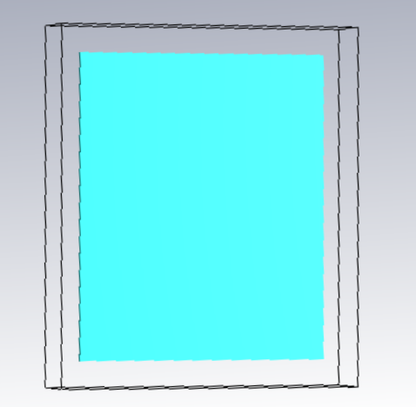

Ground Substrate

Patch Designed Antenna

**Antenna description:**

The umbrella shape antenna is derived from a basic circular patch. To increase the bandwidth of the conventional circular patch antenna which has a narrow bandwidth, the circular embedding slot and defected ground techniques on the periphery of the patch antenna are used. The substrate of the anticipated antenna is made of jeans with a thickness of 1.076 mm. The advantage of the low dielectric constant of jeans is that it enhances the bandwidth and reduces the surface wave losses.30,31 The overall dimension of the mentioned antenna is 40 * 40 * 1.076 mm2 (1.32 1.32 0.035 λ3 0). The dielectric permittivity (εr), thickness (t), and loss tangent (tanδ) values are shown in Table 1. Equation (1) is used to compute the radius of the patch.

R = $\frac{87.94}{f_{r\sqrt{∈_{r}}}}$

**Antenna simulation**

CST software is utilized to simulate the proposed antenna. The simulated results for each case are shown in below figure. The initial design (Case 1) consisting of a circular patch resonates in single band at 9.1 GHz with the bandwidth of 2700 MHz (8.2 to 10.9 GHz). The antenna design (Case 2, Case 3, and Case 4) gives the triple band whose frequency ranges are 6.2 to 7.1 GHz, 9.2 to 10.5 GHz, and 12.3 to 13 GHz for Case 2; 6.2 to 9.1 GHz, 9.5 to 10.5 GHz, and 11.7 to 12.75 GHz for Case 3; while 7.6 to 9.2 GHz, 9.8 to 10.7 GHz, and 11.95 GHz to 13.1 GHz for Case 4 in lower, middle, and upper bands, respectively. The proposed antenna (Case 5) has a simulated impedance bandwidth from 6 to 13.1 GHz with four resonance frequencies: f1 = 7.65 GHz, f2 = 8.51 GHz, f3 = 10.1 GHz, and f4 = 12.33 GHz. It is observed that in Case 5, the antenna has wider impedance bandwidth than the antenna designed in previous cases.

Antenna parameters are the characteristics that describe the performance and behaviour of an antenna. They include:

**Gain:** The ratio of the radiation intensity in a given direction to the radiation intensity of an isotropic antenna (an ideal antenna that radiates equally in all directions). Gain measures how well the antenna concentrates the radiated power in a desired direction.

**Bandwidth:** The range of frequencies over which the antenna operates satisfactorily. Bandwidth is usually defined by the frequency interval where the input impedance, the return loss, or the VSWR of the antenna are within acceptable limits.

**Radiation pattern:** The representation of the radiation intensity or the electric field of the antenna as a function of the angular coordinates. The radiation pattern can be plotted in 3-D or 2-D, and it shows the directional properties and the beam shape of the antenna.

**Beamwidth:** The angular span of the main lobe of the radiation pattern, measured between the points where the radiation intensity drops to half of its maximum value. Beamwidth indicates the angular resolution and the coverage area of the antenna.

**Polarization:** The orientation and the variation of the electric field vector of the electromagnetic wave radiated or received by the antenna. Polarization can be linear, circular, or elliptical, and it depends on the shape and the orientation of the antenna.

**Impedance:** The ratio of the voltage to the current at the input terminals of the antenna. Impedance determines how well the antenna is matched to the transmission line or the source impedance. A good impedance match means that most of the power is delivered to the antenna, while a poor impedance match means that a large portion of the power is reflected back to the source, causing losses and interference.

**Parametric study**

The line feed length (Lf) and ground length (Lg) of the proposed antenna are varied to compare their performance.

**Variation in length of the feed-line**

The deviation of return loss for different values of feed length (Lf) is presented. The lower resonance frequencies are shifted to the right as the feed length is decreased. The antenna shows multiband characteristics as the feed length (Lf) is increased, and there is no effect observed in higher resonance frequencies.

**Variation in the width of the feed-line**

The effect of varying feed width (Wf) at fixed value of feed length (Lf = 10 mm) on return loss characteristics. The antenna achieves multiband operation as the values of Wf are increased for 1 mm, while the lower and upper resonance frequencies are shifted to the left. Furthermore, the bandwidth is improved at feed width 2 mm. Therefore, the optimum value of Wf is 2 mm which is the most suitable value for the fabricated prototype.

**Variation in the size of the ground plane**

The results obtained by varying the size of partial ground length (Lg) from 18 to 22 mm at fixed feed length (Lf = 10 mm) and fixed feed width (Wf = 2 mm) are presented in Figure 5. The bandwidth is significantly decreased as the values of Lg are increased above 20 mm, and the resonance frequency is shifted to the right. Thus, Lg = 20 mm is optimum, and the bandwidth from 6 to 13.1 GHz is obtained.

**Variation in the radius of patch**

The effect of varying the radius (R) from 14 to 18 mm of the circular patch at fixed feed length (Lf = 10 mm), fixed feed width (Wf = 2 mm), and fixed ground length (Lg = 20 mm) is shown in Figure 6, which gives dual-band and triple band characteristics when the radius (R) is increased, whereas for the starting values, the frequency is shifted, and no change is observed in higher frequencies.

Figure 3

**S-Parameter**

S-parameter stands for scattering parameter, which is a way of describing how electromagnetic waves propagate through a network of ports, such as an antenna. S-parameter is useful for high-frequency circuits, where voltages and currents are not easy to measure or define. S-parameter can tell us how much of the incident wave is reflected or transmitted by the antenna, and how the antenna behaves in both forward and reverse directions.

For a two-port network, such as a simple antenna, there are four s-parameters:

* S11: the input port reflection coefficient, which measures how much of the incident wave is reflected back from the input port of the antenna.
* S12: the reverse transmission coefficient, which measures how much of the incident wave is transmitted from the input port to the output port of the antenna.
* S21: the forward transmission coefficient, which measures how much of the incident wave is transmitted from the output port to the input port of the antenna.
* S22: the output port reflection coefficient, which measures how much of the incident wave is reflected back from the output port of the antenna.

S-parameters are usually expressed in decibels (dB), which is a logarithmic scale that compares the power ratio of the waves. A negative s-parameter value means that the power is reduced, while a positive s-parameter value means that the power is increased. For example, if S11 = -10 dB, it means that the reflected power is 10 times less than the incident power, which indicates a good impedance match.

S-parameters can be used to determine various antenna parameters, such as:

* **Return loss:** the ratio of the incident power to the reflected power in dB. It is equal to the absolute value of S11 or S22. A higher return loss means a better impedance match and a lower voltage standing wave ratio (VSWR).
* **Insertion loss:** the ratio of the incident power to the transmitted power in dB. It is equal to the negative value of S21 or S12. A lower insertion loss means a higher efficiency and a higher gain of the antenna.
* **Bandwidth:** the range of frequencies over which the antenna operates satisfactorily. It is usually defined by the frequency interval where the s-parameters are within acceptable limits. For example, a common criterion for bandwidth is that S11 or S22 should be less than or equal to -10 dB, which corresponds to a VSWR of 2:1 or less.
* **Radiation pattern:** the representation of the radiation intensity or the electric field of the antenna as a function of the angular coordinates. It can be derived from the s-parameters by using the antenna factor, which is the ratio of the electric field to the voltage at the antenna terminals.

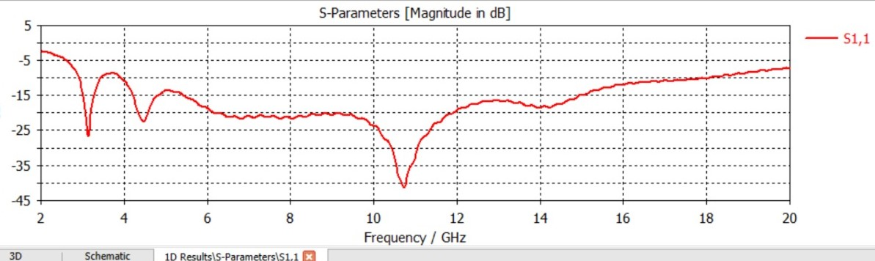

S-Parameter

**Voltage Standing Wave Ratio (VSWR)**

VSWR stands for voltage standing wave ratio, which is a measure of how well the antenna impedance matches the feed line impedance. A low VSWR means that most of the power is radiated by the antenna, while a high VSWR means that some of the power is reflected back to the source. The VSWR of a microstrip patch antenna depends on the frequency, the substrate thickness, the feed method, and the antenna shape and size. A typical VSWR bandwidth for a microstrip patch antenna is around 5% to 10%.

Voltage Standing Wave Ratio (VSWR)

**Surface currents and radiation pattern**

The surface currents radiated by the proposed umbrella shape antenna at 8.51, 10.1, and 12.33 GHz are depicted in the two-dimensional surface plots. It is observed that at 8.51 GHz, most of the current having amplitude 152 A/m is on microstrip line. At 10.1 GHz, there is a strong current on the circular slot along with ML, and the current amplitude is 154 A/m. However, at 12.33 GHz, the current amplitude is 122 A/m.

The simulated 3D radiation pattern of the antenna designed in CST microwave software is shown in Figure 8. Moreover, the directivity obtained at resonance frequency 8.51 GHz is 3.28 dB is presented. For the resonance frequencies, 10.1 and 12.33 GHz, directivities are 4.91 and 6.15 dB, respectively.

Radiation pattern in antenna is a graphical representation of how the antenna radiates or receives electromagnetic waves in different directions. It shows the relative strength and the shape of the radiation field of the antenna. Radiation pattern can be used to evaluate the performance and the characteristics of the antenna, such as gain, directivity, beamwidth, polarization, and impedance[1](https://www.tutorialspoint.com/antenna_theory/antenna_theory_radiation_pattern.htm)

Radiation pattern can be plotted in three-dimensional or two-dimensional forms, using spherical or polar coordinates. The three-dimensional plot shows the radiation intensity as a function of the azimuth and elevation angles, while the two-dimensional plot shows the radiation intensity as a function of one of the angles, usually at a constant radius. The two-dimensional plot can be divided into horizontal and vertical planes, which are also called H-plane and E-plane, respectively.

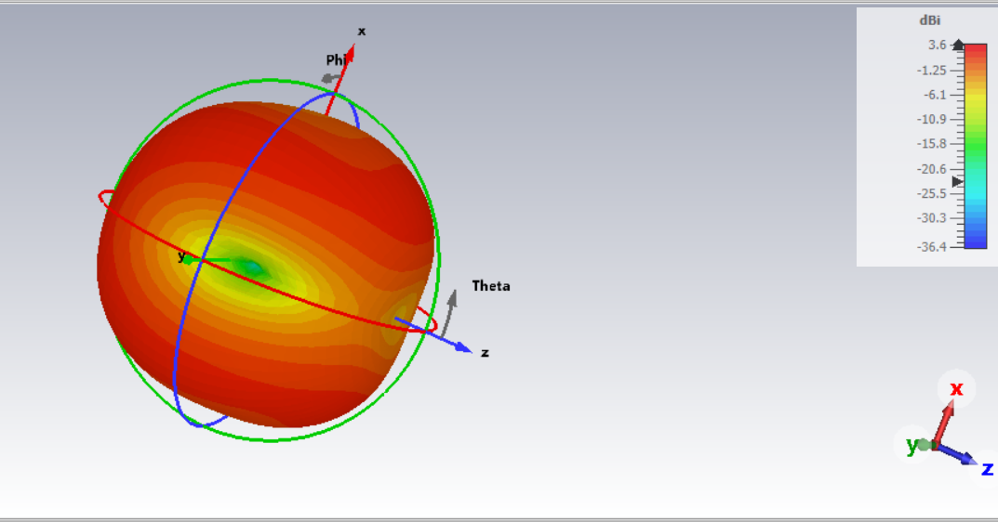Radiation pattern can also be classified into different types of lobes, which are the regions where the radiation intensity is relatively high. The main lobe is the lobe that has the maximum radiation intensity and points in the desired direction of propagation. The side lobes are the lobes that have lower radiation intensity than the main lobe and point in other directions. The back lobe is the lobe that points in the opposite direction of the main lobe.

Radiation Pattern

**Bending effect on antenna**

The effect of bending on the performance of the proposed antenna which is flexible is an essential aspect of the studies done. In practical applications, the antenna could be located on the chest, shoulder, or wrist in varying degrees of bending. Software simulations are performed for different bending radius. The bending effect in different planes is studied, such as XZ-plane convex and XZ-plane concave. The flexible antenna's overall response by varying bending angles is reported in terms of return loss (jS11j) curve. The bending along the horizontal convex (XZ-plane upward), a small increase in the return loss, is observed, and for all bending angles, antenna has UWB as depicted in Figure 9. As the antenna bending increases along the horizontal concave, the resonance frequencies are shifted to the right. The return loss curve for the concave condition is depicted.

The body model available in CST software is used to study the antenna behavior on the human body. The model used was the “Gustav”, which has 176 cm with 69 kg of mass. While performing the simulation, the electrical parameters of human skin, fat, and muscle are the same as IEEE and FCC.

The antenna is positioned on the human arm with a radius of 70 mm to study the bending effect and the SAR simulation is carried out at 10.1 GHz. The SAR values for other frequencies considering a source power of 100 mW.

Ultrahigh-frequency electromagnetic energy can cause biological effects in humans, the prime effect being heating of human tissue which contains water. It absorbs the energy in the radiated microwave and produces heat. Tissue damage in humans could occur during exposure to high RF levels because of the body's inability to dissipate the excessive heat that is generated. The eyes and the testes are particularly vulnerable to RF heating due to the relatively lower blood flow to dissipate the excess heat.

The averaged 10 g SAR at resonance frequencies when the antenna is placed on the voxel model's left arm. In calculated SAR values, the maximum value is 1.84 W/kg at 12.33 GHz, and the minimum is 0.8316 W/kg at 7.65 GHz.

**REFERENCES**

1. Corchia L, Monti G, Tarricone L. Wearable antennas: nontextile versus fully textile solutions. IEEE Antenn Propag Mag. 2019;61(2):71-83. doi:10.1109/MAP.2019.2895665

2. Bariya M, Nyein HYY, Javey A. Wearable sweat sensors. Nature Electron. 2018;1:160-171. doi:10.1038/s41928-018-0043-y

3. Alarifi A, Al-Salman A, Alsaleh M, et al. Ultra wideband indoor positioning technologies: analysis and recent advances. Sensors. 2016; 16(5):1-36. doi:10.3390/s16050707

4. Hertleer C, Rogier H, Vallozzi L, Langenhove LV. A textile antenna for off-body communication integrated into protective clothing for firefighters. IEEE Trans Antenn Propag. 2009;57(4):919-925. doi:10.1109/TAP.2009.2014574

5. Federal communications commission, revision of part 15 of the commission's rules regarding ultra-wide-band transmission systems. First Report and Order FCC 02–48, Washington, DC, USA; 2002.

6. Rani RB, Pandey SK. Metamaterial inspired printed UWB antenna for short range RADAR applications. Microw Opt Tech Lett. 2017; 59(7):1600-1604.

7. Abayaje F, Febvre P. A small size monopole UWB antenna used for short distance wireless baseband transmission at high data rate. 2017 international workshop on antenna technology: small antennas, innovative structures, and applications (iWAT); 2017;296-299. doi: 10.1109/IWAT.2017.7915384

8. Rao PK, Mishra R. Multi band antenna with multi band notch 2.5/3.7/6.4/8.1/12.4/14.4GHz characteristics. 2018 5th IEEE Uttar Pradesh section international conference on electrical, electronics and computer engineering (UPCON); 2018;1-5. doi:10.1109/UPCON.2018. 8596938